Background:
On December 8, 2021, the FDA granted emergency use authorization (EUA) of tixagevimab/cilgavimab for the prevention of Covid-19 infection for specific high-risk groups. The primary data supporting this EUA came from the PROVENT study, a double blind randomized clinical trial that enrolled adults ages 59 or older with a prespecified chronic medical condition and at increased risk of SARS-CoV2 infection who had not been vaccinated or had a prior or current history of infection. In the primary analysis, those who received tixagevimab/cilgavimab had a 77% reduction in incident infection and this reduction was maintained for 6 months.

The EUA has emphasized the following groups should be prioritized:

Individuals who are not currently infected with SARS-CoV-2 and who have not had a known recent exposure to an individual infected with SARS-CoV-2 and
- who have moderate to severe immune compromise due to a medical condition or receipt of immunosuppressive medications or treatments and may not mount an adequate immune response to COVID-19 vaccination or
- For whom vaccination with any available COVID-19 vaccine, according to the approved or authorized schedule, is not recommended due to a history of severe adverse reaction (e.g., severe allergic reaction) to a COVID-19 vaccine(s) and/or COVID-19 vaccine component(s).

Per the NIH Covid Treatment Panel, in times of scarcity, individuals with severe immune compromise should be prioritized.

Medical conditions that result in severe immune compromise include:
- Patients who are within 1 year of receiving B-cell depleting therapies (e.g., rituximab, ocrelizumab, ofatumumab, alemtuzumab)
- Patients receiving Bruton tyrosine kinase inhibitors
- Chimeric antigen receptor T cell recipients
- Post-hematopoietic cell transplant recipients who have chronic graft versus host disease or who are taking immunosuppressive medications for another indication
- Patients with hematologic malignancies who are on active therapy
- Lung transplant recipients at any time post transplantation
- Patients who are within 1 year of receiving a solid-organ transplant (other than lung transplant)
- Solid-organ transplant recipients with recent treatment for acute rejection with T or B cell depleting agents or are currently on a second signal inhibitor such as belatacept
- Patients with severe combined immunodeficiencies
- Patients with untreated HIV who have a CD4 T lymphocyte cell count <50 cells/mm³
Medical conditions that result in moderate immune compromise include:
- Receiving active cancer treatment for non-hematologic malignancies (e.g. myelosuppressive chemotherapy)
- Solid organ transplant on immunosuppression (>1 year)
- HSCT <2 years (without GVHD/not taking immunosuppressive meds for another indication)
- Moderate primary immunodeficiency on treatment
- Untreated/advanced HIV, CD4 count <200 but >50 cells/mm3
- SARS-CoV2 IgG seronegative after primary vaccination due to immunosuppression

A phased allocation process has taken place. At this time the main method for obtaining Evusheld is via REF 1014 (phase 3). For clarify, the three phases are outlined below.

Phase 1. January 2-January 24, 2022
The UCLA Health considered the following initial approach for risk stratification:

*on occasion a serology will be requested if patient does not fall under traditional immunosuppressive conditions

Serostatus is emphasized in part because of prior data on monoclonal antibodies (Weinrich, and colleagues NEJM Jan 21, 2021 and Recovery Collaborative group) and in part based on the primary endpoint of the study.

Phase 1. Initial Allocation Process:
A team of pharmacists and physicians (Evusheld Team) will review a database of all qualifying patients who have had 1 primary care visit or 2 subspecialty visits in the last 3 years.

The primary MD on record will be contacted to discuss the medication with patients who meet criteria. The primary MD on record shall share the EUA fact sheet (English and Spanish).

Once patient agrees, the Evusheld admin team will reach out to patient to schedule at CTRC, Bowyer, Allergy and Immunology Clinic or Connie Frank. MD from team will place order.

Phase 2. (Start date 1/24/22-present)

Individuals who meet EUA criteria while inpatient and have no hx of exposure, no symptoms or are not positive can be considered for inpatient administration of tixagevimab/cilgavimab. Teams caring for these patients should give patient fact sheet and obtain verbal consent before placing order.

Select groups will be prioritized (patients who have received full vaccination):
- Any solid organ transplant recipient
- Any patient on myelosuppressive chemotherapy
- Any patient receiving other immunosuppressive therapy including B cell depleting agents, Bruton’s tyrosine kinase inhibitors
- HIV with CD4 < 200 cells/mL

Phase 3 (start date 1/31/22-present)
Referrals via REF 1014 available to all patients who are fully vaccinated who meet moderate-severe immunosuppressive conditions listed above. Referral will be reviewed by Evusheld Team and if appropriate patients will be scheduled at select sites (See Figures 1 and 2 below). Clinicians shall review fact sheet with patients before placing referral order.

Referral Outcomes
  - Meets criteria, will schedule
  - More information needed from referring team
  - Does not meet EUA criteria
  - Meets criteria, but defer scheduling due to recent vaccination or for other reasons.

Sites:
CTRC (for patients who have not had a kidney transplant or a malignancy)
Connie Frank (for patients who have had a kidney transplant)
Bowyer (for patients who are followed by our hematology-oncology faculty
In addition, four community hematology oncology sites are currently open for administration. Each of these sites cover several other community practices.
- Ventura
- Encino
- Downtown LA
- Marina Del Rey

Bowyer remains the main hub for all other patients receiving their oncologic care at UCLA.
NW Valley – Ventura
- Ventura (HEM ONC VENTURA)
- San Luis Obispo (HEM ONC SLO)
- Santa Barbara (HEM ONC SANTA BARBARA)
- Westlake Village* - default Ventura unless by request (HEM ONC WLV 200, HEM ONC WSTLKE VLG 112, HEM ONC WSTLKE VLG 202)

NE Valley – Encino
- Encino (HEM ONC ENCINO)
- Santa Clarita (HEM ONC SANTA CLARITA)
- Porter Ranch (HEM ONC PORTER RANCH, HEM ONC PORTER RCH 301)
- Burbank (HEM ONC BURBK STE 200)
- Beverly Hills* -default Encino unless by request (HEM ONC BEVERLY HILLS)

East – DTLA
- Downtown LA (HEM ONC DTLA BLOC)
- Pasadena (HEM ONC PASADENA)
- Alhambra (HEM ONC ALHAMBRA)

Southwest – Marina del Rey
- Marina del Rey (HEM ONC MDR)
- Santa Monica Practices (Parkside and 2020)* - default MDR, unless Bowyer pt or another location by request (HEM ONC 2020 SM 230, HEM ONC 2020 SM 580, HEM ONC 2020 SM 600, HEM ONC PARKSIDE)
- Torrance (HEM ONC TORRANCE)
- Laguna Hills (HEM ONC LAGUNA HILLS)
- Irvine (HEM ONC IRVINE)

Bowyer - Westwood
- Bowyer MDs only (HEM ONC MP1 550, HEM ONC MP2 120)

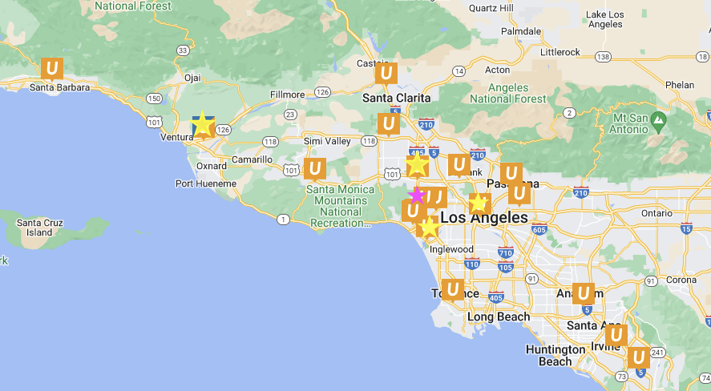

Figure 1 Workflow

Evusheld Team
Individual Clinic Teams

Figure 2 (detailed explanation of process outlined in Figure 1)

