Background:
The National Institutes of Health (NIH) Covid-19 Treatment Panel¹ has recommended the use of several treatments for outpatients with symptoms of mild-moderate COVID-19 who are at high risk for progression to severe infection. While most of these treatments have been given Emergency Use Authorization (EUA) by the Food and Drug Administration (FDA), some have been considered for off-label use based on published data.

The following guidance is for all available outpatient treatments for mild-moderate Covid-19 infection.

A quick-view summary of the approach is as follows:

Each patient should only be offered one treatment during the course of infection unless they receive a less effective treatment (such as molnupiravir or fluvoxamine from an outside source).

Treatment requirements:
Patients must meet all the following criteria to be eligible for any outpatient treatment at UCLA:
- Not requiring any supplemental O2 or increase from baseline O2 requirements
- SARS-CoV-2 positive test at least < 7 days prior (<5 days for paxlovid)
- Symptom onset < 7 days prior (<5 days for paxlovid)
- At least one high-risk criterion (see below)

High risk criteria:
- Age ≥ 65 regardless of medical co-morbidities
- Diabetes
- Immunosuppressive disease or immunosuppressive therapy (see below)
- CKD (CrCl < 60 ml/min per Cockroft-Gault for > 3 months)
- Obesity (BMI ≥ 25 or if 12-17 years BMI ≥ 95th percentile (based on CDC growth chart))
- Neurologic diseases: cerebrovascular diseases, Down Syndrome or other neurodevelopmental disorders, or dementia
- Pregnancy if other risk factors and under maternal fetal medicine consultation (consider checking antibody status)
- Hemoglobin disorders (sickle cell, thalassemia)
- Cardiovascular disease (congenital heart disease, heart failure, CAD, cardiomyopathy, or pulmonary HTN), OR Hypertension
- Chronic lung disease (COPD/emphysema, moderate-severe asthma, CF, pulmonary fibrosis)
- Medical-related technological dependence (tracheostomy, gastrostomy, or positive pressure ventilation not related to COVID-19)
- Other CDC defined high risk criteria including history of smoking, history of cancer, liver disease, well controlled HIV, mental health disorders and substance use disorders

Individuals coming from a disadvantaged socioeconomic background are also considered given their increased risk of mortality in several studies.

Prioritization in times of scarcity
The following recommendations by the NIH will be implemented during times when cases/referrals exceed supply of agents: Treatment of COVID-19 in unvaccinated or incompletely vaccinated individuals with clinical risk factors for severe illness and vaccinated individuals who are not expected to mount an adequate immune response (i.e., immunocompromising conditions).
A tiered strategy, modified from the NIH, will be used depending on supply.
Tier 1 | Unvaccinated individuals at the highest risk of severe disease (anyone aged ≥75 years or anyone aged ≥65 years with additional risk factors) OR  Individuals with severe immunocompromising conditions not expected to mount an adequate immune response to COVID-19 vaccination or SARS-CoV-2 infection due to their underlying conditions, regardless of vaccine status (highest risk)
Tier 2a | Tier 2A - Unvaccinated individuals at risk of severe disease not included in Tier 1 (anyone aged ≥ 65 years or anyone aged < 65 years with clinical risk factors based on criteria above)
Tier 2b | Tier 2B - Moderate-severe immunocompromise (per CDC criteria) not otherwise included in Tier 1, regardless of vaccine status and age
Tier 3* | Vaccinated individuals at high risk of severe disease (anyone aged ≥75 years or anyone aged ≥65 years with high risk criteria other than immunosuppression)
Tier 4* | Tier 4 - Vaccinated individuals at risk of severe disease (anyone aged ≥65 years or anyone aged <65 with high risk criteria other than immunosuppression)
*Pending supply Tiers 3 and 4 may be further stratified based on absence of booster shot or only 1 J&J

Immunocompromising conditions may be stratified as follows:
Severe immunocompromising conditions (Tier 1):
- Patients who are within 1 year of receiving B-cell depleting therapies (e.g., rituximab, ocrelizumab, ofatumumab, alemtuzumab)
- Patients receiving Bruton tyrosine kinase inhibitors
- Chimeric antigen receptor T cell recipients
- Post-hematopoietic cell transplant recipients who have chronic graft versus host disease or who are taking immunosuppressive medications for another indication
- Patients with hematologic malignancies who are on active therapy
- Lung transplant recipients
- Patients who are within 1 year of receiving a solid-organ transplant (other than lung transplant)
- Solid-organ transplant recipients with recent treatment for acute rejection with T or B cell depleting agents
- Patients with severe combined immunodeficiencies
- Patients with untreated HIV who have a CD4 T lymphocyte cell count <50 cells/mm³
Moderate immunocompromising conditions (Tier 2B):
- Receiving active cancer treatment for non-hematologic malignancies (e.g. myelosuppressive chemotherapy)
- Solid organ transplant on immunosuppression (>1 year)
- HSCT <2 years (without GVHD/not taking immunosuppressive meds for another indication)
- Moderate primary immunodeficiency on treatment
- Untreated/advanced HIV, CD4 count <200 but >50 cells/mm3
- Active treatment with high-dose corticosteroids (>20mg daily for at least 2 weeks) or other drugs that may suppress your immune response (active, within the last month)
When the demand for this therapy may exceeds our ability to administer on any given day, the order time stamp and a point system, specifically prioritizing risk of disease severity and risk of exposure (including socioeconomic vulnerability), will be included in the allocation process. A lottery system may also be utilized if multiple individuals have the same risk for disease severity. We will review all referrals at 10:30am on each calendar day.

Selection of Therapies
Five* options will be considered depending on availability of treatment and contraindications:
- Sotrovimab (IV), a monoclonal antibody targeting the receptor binding domain (RBD) of the spike (S) protein
- Bebtelovimab** (IV), a monoclonal antibody targeting the RBD of the S protein
- Paxlovid (PO), a protease inhibitor: several drug interactions
- Remdesivir (IV), a nucleotide prodrug analogue targeting RNA polymerase
- Molnupiravir (PO), nucleotide analogue, introduces errors in replication: contraindicated in pregnancy (not prioritized due to low efficacy)

 | Sotrovimab  Bebtelovimab** | Paxlovid (nirmatrelavir/ritonavir) | Molnupiravir (Lagevrio) | Remdesivir
Standard Dose | Sotrovimab 500mg IV x 1  Bebtelovimab 175mg IV x1** | Nirmatrelvir 300mg (two 150 mg tablets) with 100 mg ritonavir (one 100mg tablet), with all three tablets taken together twice daily for 5 days with or without food | 800mg (4 tablets) orally every 12 hours x 5 days with or without food | 200mg IV day 1  100mg IV d2-3
Window | 7 days from sx onset | 5 days from sx onset | 5 days from sx onset | 7 days from sx onset
Efficacy | 85% risk reduction for sotrovimab, no clinical data available for bebtelovimab** | 89% risk reduction | 30% risk reduction | 87% risk reduction
Drug Interactions | None | -Substrate and inhibitor of CYP3A4.  -Review Appendix A, the drug EUA, and https://www.covid19-druginteractions.org/checker  -Must discuss management of immunosuppression with Transplant team before prescribing | None | No significant interaction
Pregnancy/  Lactation | Limited data, generally considered safe | Limited data, must be approved by MFM | Contraindicated | Limited data, generally considered safe
Renal adjustment | No adjustment | -For eGFR >30 ml/min and <60 ml/min: decrease dose to 150 mg nirmatrelvir (one 150 mg tablet) and 100 mg ritonavir (one 100 mg tablet) twice daily x 5 days with or without food  -Not recommended for eGFR < 30 ml/min | No adjustment | Discuss with pharmacy if eGFR <30
Hepatic adjustment | No adjustment | Not recommended in severe impairment | No adjustment | Not recommended if AST/ALT >10 x ULN
*Convalescent plasma in the outpatient setting is currently not available
**Bebtelovimab does not have clinical data published at this time, but has broad neutralizing activity including against BA.2

Patients must receive fact sheets and consent to treatment prior to administration.
Sotrovimab fact sheet (available in English and Spanish)
Paxlovid fact sheet (available in English and Spanish)
Molnupiravir fact sheet (English, Spanish)
Bebtelovimab fact sheets available here at this time
Remdesivir fact sheet separate and specific to UCLA Health
Remdesivir EUA for <12 or <40kg and requires a specific FDA fact sheet (English and Spanish)

How to order/refer:
The referral process for monoclonal antibody therapies is as follows: Referral for COVID-19 Outpatient Therapies [REF1012]. There are 3 places that infusions will be administered: Bowyer (for patients followed by our heme-onc colleagues), CTRC and IV League in Culver City. Select patients may receive remdesivir through Home Health.

Prescriptions for outpatient oral antivirals (Paxlovid (nirmatrelvir-ritonavir) and molnupiravir) will be sent by the Outpatient Treatment Team to the UCLA Med Plaza Level 1 pharmacy or UCLA Santa Monica 16th Street pharmacy for curbside pickup or home delivery if supply is available. We currently have a limited supply available. Please see the following workflow:
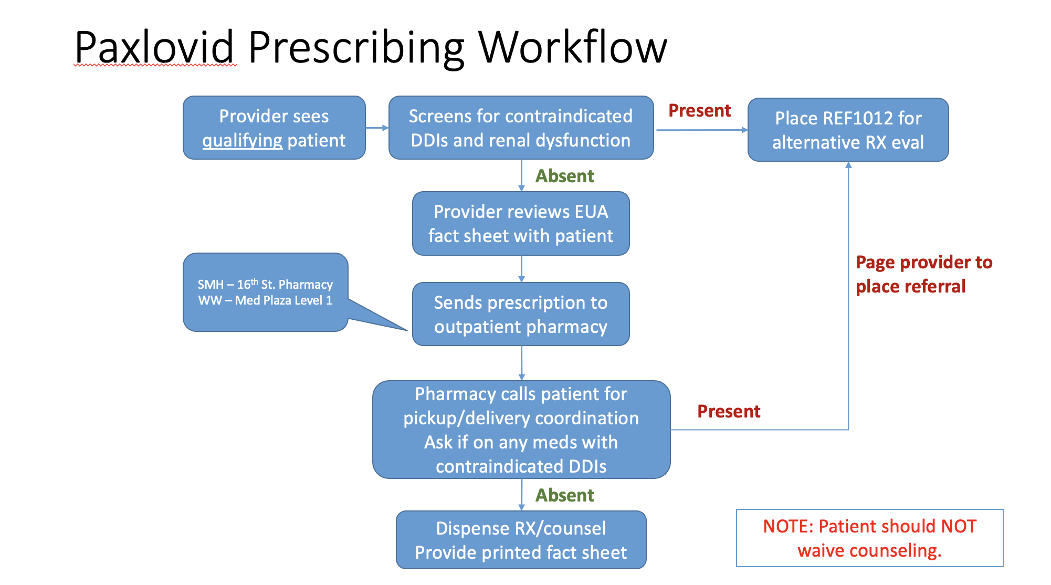

If you have eligible patients whom we are not able to accommodate with oral therapies due to supply, you can consider one of these outpatient pharmacies that carry oral antiviral therapies. Healthcare professionals must screen patient’s medication list for drug interactions (see Table below or use https://www.covid19-druginteractions.org).

Home Health
UCLA Health has partnered with 2 home health agencies (Accent Care and Intracare) to provide select patients remdesivir at home if we are unable to give them monoclonal antibodies due to supply. The decision to offer remdesivir at home will be determined by the Outpatient Covid Treatment Team.

Emergency Department Guidance:
Monoclonal antibodies (e.g., sotrovimab), when available, maybe offered to select Tier 1 or 2 patients who are seen in the emergency room. Patients should never be referred to the ED specifically for treatment. Priority will be made for those from socioeconomically vulnerable communities who are unable to access care otherwise. Alternatively, if monoclonal antibodies are not available, the Care Coordination Team in the ED can arrange for Home Health remdesivir via the two above agencies. All such decisions should be approved by Tara Vijayan, MD (Medical Director of Antimicrobial Stewardship) p31173 or the Covid ID attending on call (RRMC p89292 and SMH p89293).

In addition, patients who meet the criteria for Paxlovid (high risk, symptoms <5 days and no drug interactions) can have the medication ordered at the 200 Med Plaza Level 1 pharmacy or the SM 16th street pharmacy.

Additional resources for therapeutics outside UCLA:
https://healthdata.gov/Health/COVID-19-Public-Therapeutic-Locator/rxn6-qnx8/data
https://covid-19-therapeutics-locator-dhhs.hub.arcgis.com/

Patient facing website on UCLA treatment approach
https://www.uclahealth.org/conditions-we-treat/coronavirus/covid-19-outpatient-treatments

NIH Table of Drug Interactions with Nirmatrelavir/ritonavir (Paxlovid)
Prescribe an alternative COVID-19 therapy for patients who are receiving any of the medications listed. | Before prescribing ritonavir-boosted nirmatrelvir (Paxlovid), determine whether the patient is receiving any of the medications listed.  - If the patient is receiving any of these medications, withhold the medication if clinically appropriate.  - If withholding is not clinically appropriate, use an alternative concomitant medication or COVID-19 therapy.ª
- Amiodarone  - Apalutamide  - Bosentan  - Carbamazepine  - Cisapride  - Clopidogrel  - Clozapine  - Colchicine in patients with renal and/or hepatic impairment  - Disopyramide  - Dofetilide  - Dronedarone  - Eplerenone  - Ergot derivatives  - Flecainide  - Flibanserin  - Glecaprevir/pibrentasvir  - Ivabradine  - Lumateperone  - Lurasidone  - Mexiletine  - Phenobarbital  - Phenytoin  - Pimozide  - Propafenone  - Quinidine  - Ranolazine  - Rifampin  - Rifapentine  - Rivaroxaban  - Sildenafil for pulmonary hypertension  - St. John’s wort  - Tadalafil for pulmonary hypertension  - Ticagrelor  - Vorapaxar | - Alfuzosin  - Alprazolam  - Atorvastatin  - Avanafil  - Clonazepam  - Codeine  - Cyclosporine^{b}  - Diazepam  - Everolimus^{b}  - Fentanyl  - Hydrocodone  - Lomitapide  - Lovastatin  - Meperidine (pethidine)  - Midazolam (oral)  - Oxycodone  - Piroxicam  - Propoxyphene  - Rosuvastatin  - Salmeterol  - Sildenafil for erectile dysfunction  - Silodosin  - Simvastatin  - Sirolimus^{b}  - Suvorexant  - Tacrolimus^{b}  - Tadalafil for erectile dysfunction  - Tamsulosin  - Tramadol  - Triazolam  - Vardenafil
ª Expert consultation may be considered. In some cases, dose reduction of the concomitant medication may be an appropriate management strategy. ^{b} Before prescribing ritonavir-boosted nirmatrelvir (Paxlovid) for a patient receiving this immunosuppressant, the patient’s specialist clinician(s) must be consulted, given the significant drug-drug interaction potential between ritonavir and the narrow therapeutic index agent and because close monitoring may not be feasible.

