1. Background:

The National Institutes of Health (NIH) Covid-19 Treatment Panel1 has recommended the use of several treatments for **outpatients with symptoms of mild-moderate COVID-19 who are at high risk for progression to severe infection**.

2. Eligibility/Patient Selection:

*Each patient should only be offered one treatment during the course of infection unless they receive a less effective treatment (such as molnupiravir or fluvoxamine from an outside source).*

2. 1 Treatment requirements:

Patients must meet **all** the following criteria to be eligible for any outpatient treatment at UCLA:

* Not requiring any supplemental O2 or increase from baseline O2 requirements
* SARS-CoV-2 positive test  at least < 7 days prior (<5 days for paxlovid)
* Symptom onset < 7 days prior (<5 days for paxlovid)
* At least one high-risk criterion (see below)

2. 2 High risk criteria:

* Age ≥ 65 regardless of medical co-morbidities
* Diabetes
* Immunosuppressive disease or immunosuppressive therapy (see below)
* CKD (CrCl < 60 ml/min per Cockroft-Gault for > 3 months)
* Obesity (BMI ≥ 25 or if 12-17 years BMI ≥ 95th percentile (based on CDC growth chart))
* Neurologic diseases: cerebrovascular diseases, Down Syndrome or other neurodevelopmental disorders, or dementia
* Pregnancy if other risk factors and under maternal fetal medicine consultation (consider checking antibody status)
* Hemoglobin disorders (sickle cell, thalassemia)
* Hypertension OR Cardiovascular disease (congenital heart disease, heart failure, CAD, cardiomyopathy, or pulmonary HTN)
* Chronic lung disease (COPD/emphysema, moderate-severe asthma, CF, pulmonary fibrosis)
* Medical-related technological dependence (tracheostomy, gastrostomy, or positive pressure ventilation not related to COVID-19)
* Other CDC defined high risk criteria including history of smoking, history of cancer, liver disease, well controlled HIV, mental health disorders and substance use disorders
* Socioeconomically disadvantaged patients considered given increased risk of mortality.

2.3 Prioritization in times of scarcity:

The following tiered strategy modified from [the NIH](https://www.covid19treatmentguidelines.nih.gov/therapies/updated-statement-on-the-prioritization-of-anti-sars-cov-2-mabs/) approach will be implemented during times when referrals exceed supply. Treatment of COVID-19 in unvaccinated/ incompletely vaccinated individuals with clinical risk factors for severe illness and/or vaccinated who are unable to mount an adequate immune response (i.e., immunocompromising conditions).

|  |  |
| --- | --- |
| Tier 1 | Unvaccinated individuals at the highest risk of severe disease (anyone aged ≥75 years or anyone aged ≥65 years with additional risk factors) OR  Individuals with severe immunocompromising conditions not expected to mount an adequate immune response to COVID-19 vaccination or SARS-CoV-2 infection due to their underlying conditions, regardless of vaccine status (highest risk) |
| Tier 2a | Tier 2A - Unvaccinated individuals at risk of severe disease not included in Tier 1 (anyone aged ≥ 65 years or anyone aged < 65 years with clinical risk factors based on criteria above) |
| Tier 2b | Tier 2B - Moderate-severe immunocompromise (per CDC criteria) not otherwise included in Tier 1, regardless of vaccine status and age |
| Tier 3* | Vaccinated individuals at high risk of severe disease (anyone aged ≥75 years or anyone aged ≥65 years with high risk criteria other than immunosuppression) |
| Tier 4* | Tier 4 - Vaccinated individuals at risk of severe disease (anyone aged ≥65 years or anyone aged <65 with high risk criteria other than immunosuppression) |

*Pending supply Tiers 3 and 4 may be further stratified based on absence of booster shot or only 1 J&J

Severe immunocompromising conditions (Tier 1):

* Patients who are within 1 year of receiving B-cell depleting therapies (e.g., rituximab, ocrelizumab, ofatumumab, alemtuzumab)
* Patients receiving Bruton tyrosine kinase inhibitors
* Chimeric antigen receptor T cell recipients
* Post-hematopoietic cell transplant recipients who have chronic graft versus host disease or who are taking immunosuppressive medications for another indication
* Patients with hematologic malignancies who are on active therapy
* Lung transplant recipients
* Patients who are within 1 year of receiving a solid-organ transplant (other than lung transplant)
* Solid-organ transplant recipients with recent treatment for acute rejection with T or B cell depleting agents
* Patients with severe combined immunodeficiencies
* Patients with untreated HIV who have a CD4 T lymphocyte cell count <50 cells/mm3

Moderate immunocompromising conditions (Tier 2B):

* Active cancer treatment for non-hem malignancies (e.g. myelosuppressive chemotherapy)
* Solid organ transplant on immunosuppression (>1 year)
* HSCT <2 years (without GVHD/not taking immunosuppressive meds for another indication)
* Moderate primary immunodeficiency on treatment
* Untreated/advanced HIV, CD4 count <200 but >50 cells/mm3
* Active treatment with high-dose corticosteroids (>20mg daily for at least 2 weeks) or other drugs that may suppress your immune response (active, within the last month)

When demand exceeds supply on any given day, the order time stamp and a point system, specifically prioritizing risk of disease severity and risk of exposure (including socioeconomic vulnerability), will be included in the allocation process. A lottery system may also be utilized if multiple individuals have the same risk for disease severity. Referrals will be reviewed at 10:30am on each calendar day.

3. Selection of Therapies/Ordering:

Agents will be considered depending on availability, activity against circulating strain, and contraindications.

3.1 Available Options

* Paxlovid (PO), a protease inhibitor: several drug interactions
* Bebtelovimab (IV), a monoclonal antibody targeting the RBD of the S protein (*no published clinical data, but broad neutralizing activity including against BA.2*)
* Remdesivir (IV), a nucleotide prodrug analogue targeting RNA polymerase

Table 1: Available Options and Considerations

|  |  |  |  |
| --- | --- | --- | --- |
|  | Paxlovid (nirmatrelavir/ritonavir) | Remdesivir | Bebtelovimab |
| Standard Dose | Nirmatrelvir 300mg (two 150 mg tablets) with 100 mg ritonavir (one 100mg tablet), with all three tablets taken together twice daily for 5 days with or without food | 200mg IV day 1  100mg IV d2-3 | Bebtelovimab 175mg IV x1 |
| Window | 5 days from sx onset | 7 days from sx onset | 7 days from sx onset |
| Efficacy | 89% risk reduction | 87% risk reduction | Bebtelovimab no clinical data |
| Drug Interactions | -Substrate and inhibitor of CYP3A4  -**Review Appendix A**, the drug EUA, and https://www.covid19-druginteractions.org/checker | No significant interaction; hydroxychloroquine lowers remdesivir activity | None |
| Pregnancy/  Lactation | Limited data, must be approved by MFM | Limited data, generally considered safe | Limited data, generally considered safe |
| Renal adjustment | -For eGFR >30 ml/min and <60 ml/min: decrease dose to 150 mg nirmatrelvir (one 150 mg tablet) and 100 mg ritonavir (one 100 mg tablet) twice daily x 5 days with or without food  -Not recommended for eGFR < 30 ml/min | Discuss with pharmacy if eGFR <30 | No adjustment |
| Hepatic adjustment | Not recommended in severe impairment | Not recommended if AST/ALT >10 x ULN | No adjustment |

3.2 Dispensing Requirements

**Patients must receive fact sheets and consent to treatment prior to administration.**

Sotrovimab fact sheet (available in [English and Spanish](https://www.sotrovimab.com/))

Paxlovid fact sheet (available in [English](https://labeling.pfizer.com/ShowLabeling.aspx?id=16473) and [Spanish](https://www.fda.gov/media/155075/download))

Bebtelovimab fact sheets available [here](https://www.fda.gov/news-events/press-announcements/coronavirus-covid-19-update-fda-authorizes-new-monoclonal-antibody-treatment-covid-19-retains) at this time

Remdesivir fact sheet separate and [specific to UCLA Health](https://asp.mednet.ucla.edu/pages/asp-resources)

3.3 How to order/refer to outpatient therapies (monoclonal antibodies, remdesivir):

The referral process for monoclonal antibody therapies and outpatient remdesivir:

* Provider places order for REF1012 (**Referral for COVID-19 Outpatient Therapies)**
* Patient is assessed by Outpatient COVID-19 Treatment Team and, if eligible, scheduled for outpatient infusion at one of 3 infusion sites:
  + Bowyer (Hem-Onc patients)
  + CTRC
  + IV League in Culver City
  + Select patients may receive remdesivir via home health through our partnered agencies (Accent Care and Intracare), if monoclonal supply is unavailable per Outpatient Covid-19 Treatment Team

3.4 Oral Antivirals (Paxlovid) Ordering:

E-prescriptions for Paxlovid (nirmatrelvir-ritonavir) can be sent directly to the below pharmacies for curbside pickup if supply is available. Note: UCLA pharmacies do not carry or dispense molnupiravir.

- **Medical Plaza Level 1 Pharmacy -** Hours: Mon-Fri 8a-6p, Sat 8a-4p; 310-794-1170

- **UCLA Santa Monica 16th Street Pharmacy -** Hours Mon-Fri 8a-6p, Sat 8a**-**5p; 424-259-8520

3.4.1 Paxlovid Prescribing Workflow:

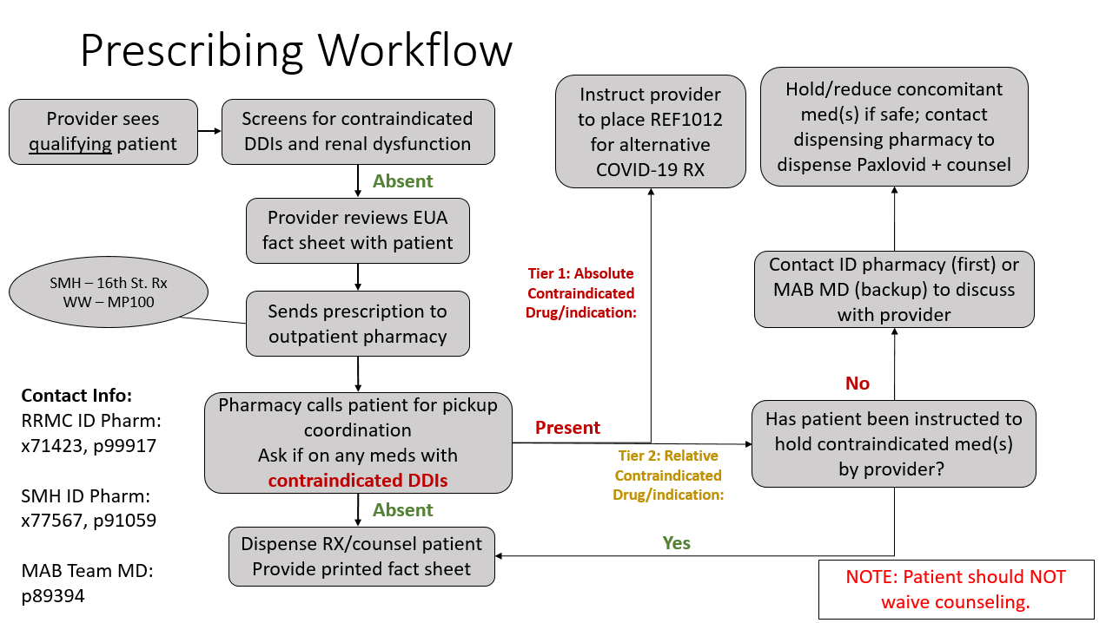

3.4.2 Limited Supply/Alternative Pharmacies

If you have eligible patients whom we are not able to accommodate with oral therapies due to supply, consider one of [these outpatient pharmacies](https://covid-19-therapeutics-locator-dhhs.hub.arcgis.com/) that carry oral antiviral therapies. Providers must screen patient’s medication list for drug interactions (see Table below or use <https://www.covid19-druginteractions.org>).

3.5 Emergency Department Guidance:

Monoclonal antibodies, when available, may be offered to select Tier 1 or 2 patients. **However,** **patients should NOT be referred to the ED specifically for treatment.** Socioeconomically vulnerable patients unable to access care otherwise will be prioritized. Alternatively, if monoclonal antibodies are not available, the Care Coordination Team in the ED can arrange for home health remdesivir via the two above agencies (See Section 3.3). All such decisions should be approved by Tara Vijayan, MD (Medical Director of Antimicrobial Stewardship) p31173 or the Covid ID attending on call (RRMC p89292 and SMH p89293).

In addition, patients who meet the criteria for Paxlovid (high risk, symptoms <5 days and no contraindicated drug interactions) can have the medication ordered at the 200 Med Plaza Level 1 pharmacy or the SM 16th street pharmacy (see Section 3.4 and 3.4.1 above).

Additional resources for therapeutics outside UCLA:

<https://healthdata.gov/Health/COVID-19-Public-Therapeutic-Locator/rxn6-qnx8/data>

<https://covid-19-therapeutics-locator-dhhs.hub.arcgis.com/>

Patient facing website on UCLA treatment approach

<https://www.uclahealth.org/conditions-we-treat/coronavirus/covid-19-outpatient-treatments>

References:

1. https://www.covid19treatmentguidelines.nih.gov/

Appendix A: Paxlovid Drug Interactions – Modified from NIH Table1

|  |
| --- |
| **Tier 1) Prescribe an alternative COVID-19 therapy** for patients who are receiving any of the medications listed. |
| * Aldosterone antagonists/K+-sparing diuretics: Eplerenone * Antiarrhythmics: Amiodarone, disopyramide, dofetilide, dronedarone, flecainide, ivabridine, mexiletine, propafenone, quinidine * Antianginal: Ranolazine (if used as an antiarrhythmic) * Anticoagulants: Apixaban/rivaroxaban (if used for VTE) * Antiplatelet: Clopidogrel, ticagrelor, vorapaxar * Antipsychotics: Lurasidone, pimozide, clozapine, lumateperone * Benzodiazepines: Midazolam (oral) * Cystic fibrosis: Lumacaftor-ivacaftor * Ergot derivatives: Dihydroergotamine, ertogamine, methylergonovine * Gout: Colchicine (if taking daily for gout prevention and severe hepatic/renal impairment) * Hepatitis C antivirals: Glecaprevir/pibrentasvir * Immunosuppressants: Cyclosporine, everolimus, sirolimus, tacrolimus, voclosporin * Opioids: Fentanyl, meperidine * PDE5 Inhibitors: Sildenafil, tadalafil, vardenafil (if used for pulmonary hypertension) * Pulmonary HTN: Bosentan * Strong CYP3A4 inducers: Apalutamide, carbamazepine, phenobarbital/primidone, phenytoin, rifampin, rifapentine, St. John’s Wort * Misc: Flibanserin, lomitapide |
| **Tier 2)** If the patient is receiving any of these medications, **hold or dose adjust the concomitant medication if clinically appropriate (see individual agents for specific instructions)**. If withholding is not clinically appropriate, use an alternative COVID-19 therapy.  Generally, ritonavir inhibitory effects are no longer present three days after final dose, this effect can be prolonged in elderly patients/renally impaired. Agents with wide therapeutic index/low risk of severe outcome **can be held for 8 days** from first Paxlovid dose, narrow therapeutic **index/high toxicity risk agents may need to be held for 10 days**. |
| * Anticoagulants: Apixaban/rivaroxaban - Can hold x 10 days if used for atrial fibrillation * Alpha-1 Antagonists: Alfuzosin, sildosin, tamsulosin – Can hold x 8 days * Benzodiazepines: Alprazolam*, clonazepam, diazepam, midazolam (oral), triazolam – Can hold x 8 days; *alprazolam dose can be decreased by 50% with monitoring * Contraceptives (oral combination): Consider backup non-hormonal contraceptive * Chemotherapy (oral): Consult individual agent drug interactions, discuss any adjustments with hem-onc provider * Gout: Colchicine – if taking PRN and no severe hepatic/renal impairment – Can hold x 10 days * Long-acting beta agonists (inhaled): Salmeterol (Brand names: Serevent, Wixela; Component of Advair Diskus) – Can hold x 8 days; Can consider temporary substitution with non-salmeterol LABA (e.g. formoterol-based [Dulera, Symbicort]) * Opioids: Codeine, ^hydrocodone, ^oxycodone, meperidine, tramadol – Can hold x 10 days; ^oxycodone dose can be decreased by 75% with monitoring, hydrocodone dose can be decreased by 50% with monitoring * PDE5 Inhibitors: Avanafil, sildenafil, tadalafil, vardenafil – Can hold x 8 days if used for erectile dysfunction * Statins: Atorvastatin, lovastatin, rosuvastatin, simvastatin – Can hold x 8 days |

a The EUA for ritonavir-boosted nirmatrelvir suggests that individuals who use products containing ethinyl estradiol for contraception should use a backup, non-hormonal contraceptive method because ritonavir-boosted nirmatrelvir has the potential to decrease ethinyl estradiol levels. However, the enzyme-inducing effects are not expected to be clinically significant during 5 days of therapy and would not be expected to decrease contraceptive effectiveness. In addition, ethinyl estradiol is combined with a progestin and exposure would be unchanged or increase with ritonavir which maintains the effectiveness of the oral contraceptive.